Having a blood test
The doctor has asked you to have a blood test.
The blood test can help the doctor decide what treatment you may need
Why do I need a blood test?

You will feel a small pin prick or scratch nut after this it will be painless. You may get a bruise or a small lump, but this will fade
Will it hurt?

Please tell the person taking blood if you are afraid of needles or have had any problems with blood tests before.
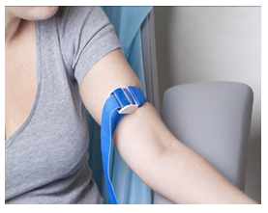
What if I am worried?

A member of staff will put a band around your arm just above your elbow.

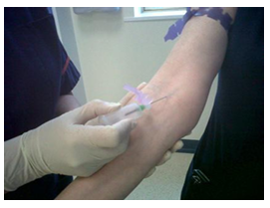
A small needle will be put into your arm which may feel like a small pin prick.

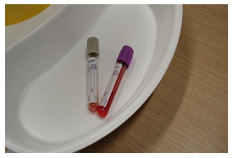
Blood will then go into the small sample bottled and the needle removed.

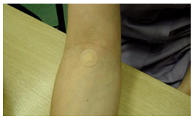
A plaster will be put on.
Tell staff if plasters give you a rash or redness.
The test is finished and you can leave.

They are sent to be tested and the doctor will receive most results within 7 days
What happens to the
blood samples?
The doctor may need to talk to you about your results.
If you have not had your results within 10 days you can ring the surgery on 014523 543000

How do I get my results?

